HMS Soccer Schedule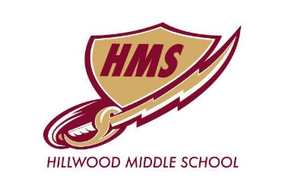
2022
4/7 Medlin Middle School AWAY @ Medlin Middle School
4/14 Coppell North @CHS
4/21 Tidwell Middle School @CHS
4/28 Indian Springs AWAY @ Indian Springs Middle School
5/3 Keller Middle School @ Hillwood
5/11 Coppell West AWAY @ Coppell West Middle School
5/13-5/14 Top 4 Tournament @ TBD

